SVM Digital Voucher scheme information sheet

How the voucher scheme works:

The organisation will receive emails with links to the SVM voucher portal which they then need to click on so that they can pick a supermarket & receive their voucher.

Either this email can go directly to the family or you can manage the process for them & then print off the voucher. We call the people receiving the vouchers in this document the ‘beneficiary’.

What happens after you have placed your orders?

- On the working day following an order being submitted, an email will be sent to the email address provided. This email will invite the recipient to follow a link to select their supermarket (eCode) and also outlines the timescales for delivery of the store eCode, depending on which retailer is selected.

- The following working day, the email address specified on the order will receive an email from no-reply@svmglobal.com with the subject line ‘Award eCode’ inviting the email recipient to follow a link to select their voucher:

- Multiple supermarket eCodes can be selected, up to the total value awarded. Once all eCodes have been selected the beneficiary can check out and will be asked to confirm delivery details. An order confirmation will then be sent to the beneficiary, followed by a link to the store eCode within the timescales specified.

Retailers
The following store vouchers will be available to the beneficiary: Asda, Tesco, Sainsbury’s & Morrisons.

Each retailer operates their own terms and conditions for vouchers, details of all Ts & Cs can be viewed on the Award eCode website.

Check out
The beneficiary will be able to select any number of store vouchers totalling up to the value awarded. If the beneficiary attempts to proceed to check out without selecting vouchers to the full awarded value, a warning will be displayed that the remaining balance will be lost. The beneficiary will be able to return to the site to add/amend vouchers in their basket. The retailer vouchers can be used for multiple transactions so there is no reason not to check out the full balance.

Please be aware that once the beneficiary has checked out, they will not be able to change their choice. Any value not redeemed will be lost and cannot be recovered.

Please also note that SVM have different denominations for certain stores:
- Asda values available are £5, £10, £25, £50 (you can double, triple etc these amounts)
- Morrison’s values are available as £10, £25 and £50 (you can double, triple etc these amounts)
- Sainsbury’s remain open-value, minimum value is £1
- Tesco remain open-value, minimum is £5

- Please ensure that you are only awarding SVM vouchers that end with 5 or 0 so that you are not losing money on checkout when using Asda & Morrisons

Expiry Process for Unredeemed Awards:
- When the initial link is received, the beneficiary will have two months to redeem their voucher
- Awards will be automatically expired after two months & fully unspent awards will then be returned to the council using the expiry process

*Please see beneficiary information below*

To receive your supermarket vouchers, you will receive an email with a link to the SVM portal where you can choose between 4 supermarkets & redeem your vouchers.

- You will receive an email from no-reply@svmglobal.com with the subject line ‘Award eCode’ inviting the email recipient to follow a link to select their voucher:

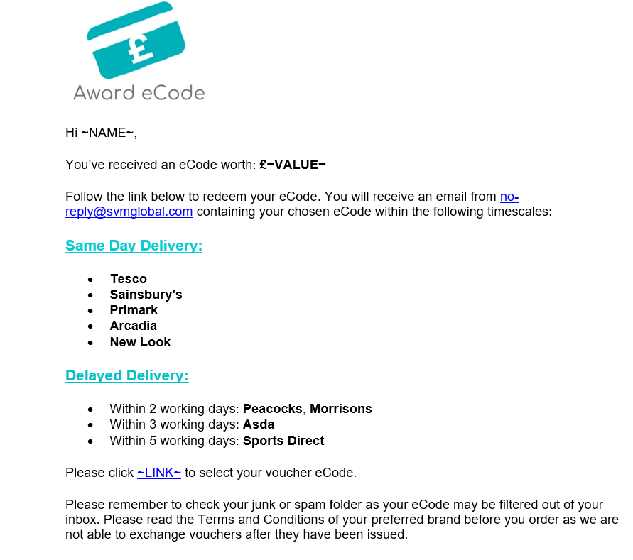

- By following the link, the email recipient will be taken to the Award eCode site where they can select their voucher from the category (food or clothing) awarded:

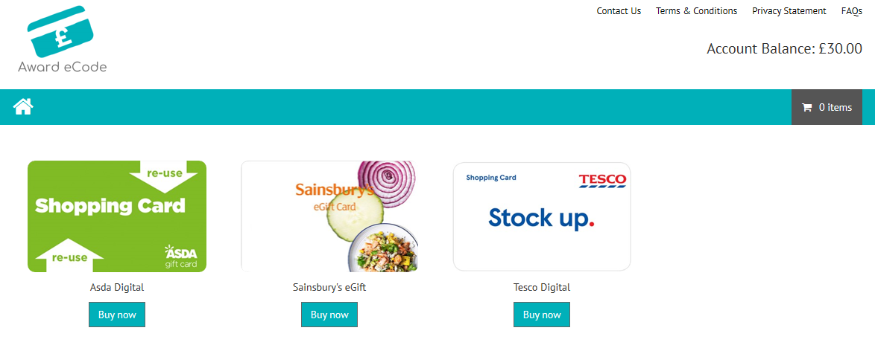

- Please be aware that each retailer operates their own terms and conditions for the vouchers they offer. These will be displayed before the voucher(s) is added to the basket.

- The value awarded can be split across one or more voucher types, but all must be selected at the same time. If check out is attempted without adding vouchers to the basket totalling the full amount awarded a warning notification will be shown on the screen that the additional value will be lost.

- At this point you will be asked to enter an email address:

- Whichever email address you enter will receive the order confirmation/voucher

- Following this the person whose email address was entered at point 5. above will receive an email from no-reply@svmglobal.com confirming the order:

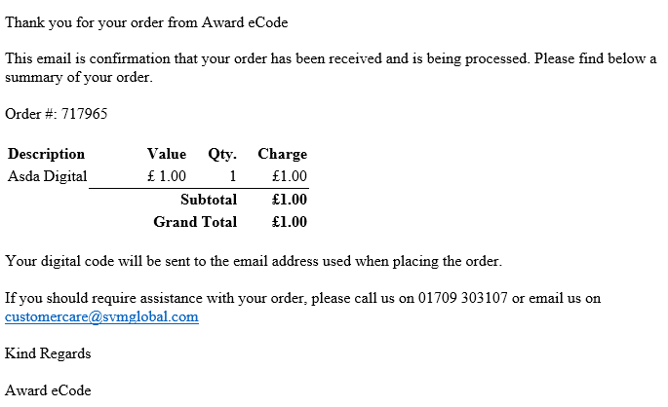
- Following this the person whose email address was entered at point 5. above, will receive an email with their voucher code from your.egift@digitalgateway.online within the timescales specified for the relevant retailers:
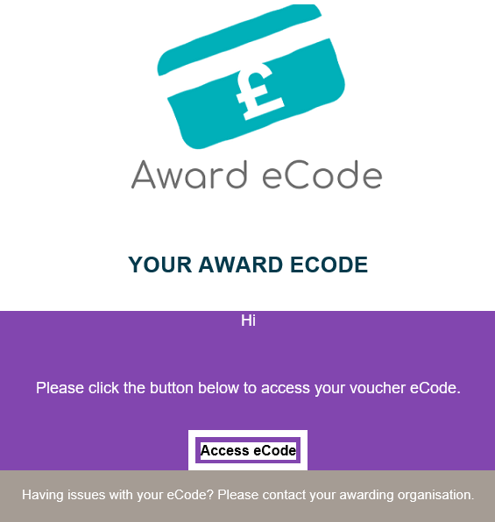
- This email contains a link to the eVoucher on the retailer’s site, which can be used in accordance with the Terms and Conditions specified by that retailer.

Retailers to choose from:
- Asda
- Morrisons
- Sainsbury’s
- Tesco

- Ensure that you are redeeming the whole award amount on check out
- Asda vouchers can now also be used for online shopping but the others must be used in-store
- All vouchers can either be printed or shown on a mobile device

Expiry Dates for each store:
- Tesco – 5 year from last transaction
- Asda – 24 months from last transaction
- Sainsbury’s - 24 months from last transaction
- Morrison’s – 12 months from last transaction

Expiry Process for Unredeemed Awards:
When the initial link is received, you have two months to redeem your voucher, after this the money will be returned to the council.

Delivery Timescales

Once you have checked out on the Award eCode site, the selected eCodes (vouchers) will be delivered via email within the timescales below.

24 hours: | Tesco & Sainsbury’s
Within 3 working days: | Morrisons & Asda

